Mini Project Report
On
Stock Price Analysis & Prediction App

Submitted by

PRN | Name of the student
1262251746 | Varad Salunke
1262251720 | Soham Gaikwad
1262253656 | Sam Moncy
1262253297 | Naman Hurkat
1232253371 | Vedant Kute

Under the Guidance of

Prof. Dr. Renuka Amit Mane
Abstract:
This project presents an interactive and data-driven system for stock market analysis and prediction using Python, Streamlit, and machine learning techniques. Leveraging real-time historical market data obtained through the yfinance API, the application performs comprehensive preprocessing and visual exploration using pandas and matplotlib. Users can dynamically inspect price movements, moving averages, and custom time-range trends through an intuitive interface.
A Linear Regression model is developed to learn the relationship between opening and closing prices, enabling analytical insights into market behaviour. The model’s performance is evaluated through actual-versus-predicted visualizations, followed by an automated 10-day forecast that simulates future price trajectories. The final outcome is a seamless, user-friendly analytical platform that combines financial data visualization, predictive modelling, and interactive exploration—offering a practical demonstration of how machine learning can support informed decision-making in financial markets.

List of Abbreviations:

MA | Moving Average
MA100 | 100-Day Moving Average
MA200 | 200-Day Moving Average
LR | Linear Regression
Open | Opening Price of Stock
Close | Closing Price of Stock
High | Highest Price of Stock in a Day
Low | Lowest Price of Stock in a Day
RSI | Relative Strength Index
ticker | Stock symbol entered by the user
preset | Predefined time range selected for data
Future predictions | Predicted closing prices for upcoming days

List of Figures:
Figure No. | Figure Name | Page No.
1 | Screenshots of output | 8

Table Of Contents:

Serial No. | Item | Page No.
1 | Introduction | 5
3 | Problem Statement | 6
2 | Python Concepts Used | 7
4 | Screenshot of output | 9
5 | Conclusion | 10
6 | References | 11

Introduction:
The stock market is dynamic, with prices constantly changing due to various economic and market factors. Predicting stock prices is important for investors to make informed decisions. This project develops a Python-based application using Streamlit and linear regression to analyse historical stock data, visualise price trends, and forecast future closing prices. The tool offers interactive charts, moving averages, and a 10-day price prediction, enabling users to efficiently understand market behaviour and trends.
- Aim:
To develop a Python-based application that analyses historical stock data and predicts future closing prices.
- Objectives:
- Fetch historical stock data.
- Visualise price trends and moving averages.
- Predict future prices using Linear Regression.
- Provide an interactive Streamlit interface.

Problem Statement:
Stock prices change every day, and predicting them manually is difficult. This project uses Linear Regression to predict future stock closing prices. It fetches historical stock data with yfinance, processes it with pandas and numpy, visualises trends and moving averages with matplotlib, and provides an interactive interface using Streamlit. The application helps users understand stock behaviour and make better decisions easily

Python Concepts Used and Explanation:
- Functions:
- yf.download() to fetch historical stock data.

- LinearRegression() for creating the predictive model.

- train_test_split() to split data into training and testing sets.

- Libraries Used :
- •pandas: To store and manipulate stock data in DataFrames.
- •numpy: For numerical operations and handling arrays.
- •matplotlib.pyplot: To plot charts for stock prices and moving averages.
- •yfinance: To fetch historical stock data from Yahoo Finance.
- •streamlit: To create an interactive web interface.
- •datetime: To handle dates and compute ranges for stock data.
- •sklearn.linear_model (LinearRegression): To train the model and predict stock prices.
- • sklearn.model_selection (train_test_split): To divide data into training and testing sets.

- Loops and Iteration :
- •for loops were used to generate future predictions for 10 days.
- •Iteration over DataFrame rows for plotting and calculating moving averages.

- Conditional Statements :
- if-elif-else statements were used to select date ranges and chart options.
- Data Structures:
- •Lists: To store future predictions.
- •DataFrames: To organise stock data and predictions.

- Plotting and Visualisation:
- Plots were created for Open, Close, High, and Low prices.
- Moving Averages (100-day and 200-day) were visualised.
- Actual vs predicted prices were plotted to show model performance.
- User Input Handling :
- Streamlit widgets like st.text_input() and st.selectbox() were used to get ticker symbols and date ranges from the user.

Screenshots of Output:
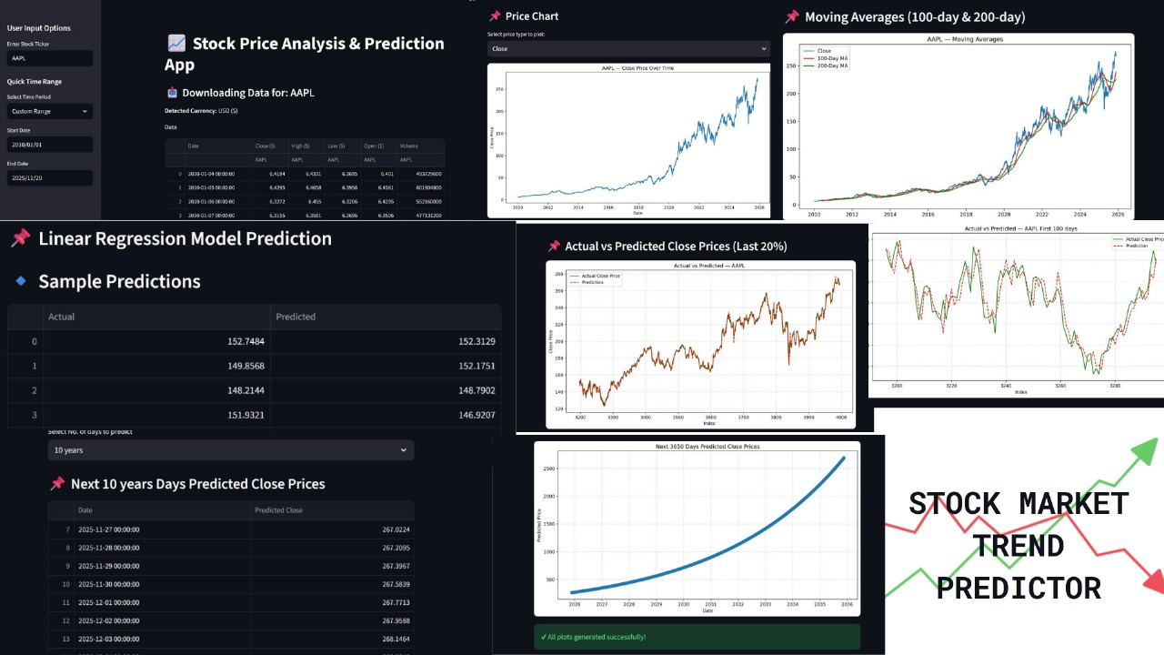

Conclusion:
In this project, we developed a Python-based application to analyse and predict stock prices using Linear Regression. The application fetches historical stock data using yfinance, processes it with pandas and numpy, visualises trends and moving averages with matplotlib, and provides an interactive interface with Streamlit.
The model successfully predicts future closing prices and shows trends through charts, helping users understand stock behaviour easily. This project demonstrates how simple machine learning techniques can be used to make stock market analysis more accessible and support better investment decisions.

References:
Data Manipulation
- Pandas Official Documentation
- NumPy Documentation
Visualization
- Matplotlib Documentation
- Streamlit Documentation
Machine Learning & Data Sources
- Scikit-learn Documentation
- Yahoo Finance API (via yfinance)
Additional Learning
- Academic lecture notes on stock analysis and regression modelling
- Online tutorials and resources for financial data science

